ALRESFORD & DISTRICT
HORTICULTURAL SOCIETY
PRODUCE, FLOWER & CRAFT SHOW SCHEDULE 2022
SATURDAY 3rd SEPTEMBER
TICHBORNE PARK
Near ALRESFORD
(By kind permission of
Tichborne Estates & Grange Farm Partnership)

Exhibiting is open to members and non-members

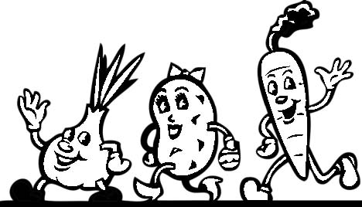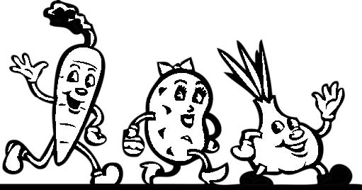

Held in conjunction with the
ALRESFORD and DISTRICT AGRICULTURAL SHOW

SHOW RULES for ENTRIES

1. All exhibits must be the bona-fide property of, and have been grown in the garden of the exhibitor, except in Sections E, F, G, H, J, & K .

2. Only one entry per person in any one class.

3. The Committee reserves the right to withdraw any prize should the judges consider the entries of insufficient merit.

4. Points for special prizes: 1st - 3 points, 2nd - 2 points, 3rd - 1 point.

5. The Show Tent will be open from 5.30pm to 7.30pm on Friday the 2nd September, and from 7.00am on Saturday 3rd September for entries to be staged. For those exhibitors who will be setting up on Friday evening and/or Saturday morning but not attending the Agricultural Show please call the Horticultural Show Manager. See entry forms (pages 10 & 11) for more details.

ALL EXHIBITS MUST BE STAGED BY 8.30am ON SHOW DAY, WHEN THE TENT WILL BE CLOSED FOR JUDGING AT 8.45am

6. Entries close at 5.00pm on Tuesday, 30th August - See Entry Form.

7. Prize-giving will be at approximately 4.30pm – see poster in show tent for confirmation.

PLEASE LEAVE EXHIBITS IN PLACE UNTIL THE PRIZES HAVE BEEN PRESENTED.

8.. The Committee will not hold themselves responsible for any loss, but every care
will be taken by the stewards.

9. All entry forms and fees to be deposited in the box at D&G Hardware, Broad Street, Alresford or can be posted or delivered to 22 Sun Hill Crescent, Alresford SO24 9NJ
Email -ann.winfield505@gmail.com

Page 2
10. For the purposes of this schedule, a Novice is one who has not previously won a cup, plaque, medallion or certificate (not a prize card) at this show for an exhibit in the relevant section.
NB Children may exhibit in all classes subject to the rules shown.

11. Any Competitor who has won the Banksian Medal in the last 2 years is not
eligible to win this medal.

12. The rules of the R.H.S., N.D.S., N.A.F.A.S., N.R.S., will be followed in judging the
produce exhibited has been cultivated by the person named on the entry form.

13. Any dispute arising will be settled by the Judge and Show Manager, whose decision shall
be final.

14. Any enquiry about the schedule should be made to:- Show Manager, Mrs Ann Winfield,
Tel: 01962 867596

HINTS & INFORMATION FOR EXHIBITORS

The Show is open for everyone to enter
Not entered before? Why not enter a Novice class?

The single most important rule is to READ THE SCHEDULE. (e.g. number required) so that that your exhibit is not classed as N.A.S. (Not According to the Schedule).and disqualified. Try to make your exhibit look as attractive as possible. All exhibits, whether they win a prize or not, go to make up the Show.
Evenness, freshness and freedom from disease are more important than size, unless stated.

EXHIBITORS SHOULD COLLECT THEIR EXHIBITOR ENTRY CARDS FROM THE SECRETARY’S TABLE IN THE MARQUEE ON ARRIVAL.
Before judging, the stewards will make sure that all the entry cards are turned over, so that the exhibitor’s name is not visible. After judging, they will be placed face upwards

Page 3

VEGETABLES
They should be cleaned, using plenty of water and a sponge. It makes for better presentation if tops are trimmed and bound with raffia, or an equivalent. Be careful when lifting carrots and parsnips not to break the long “tail”.

(i) Parsnips, carrots, cabbages, beans and beetroot are laid on the table
(ii) Potatoes, tomatoes, shallots and peppers are best placed on a white paper plate
(iii) Shallots should be mounted on a dish of dry sand, and onions on cardboard rings,
such as ones cut from kitchen roll containers
(iv) Brassicas should have not less than 75mm of stump left
(v) All varieties of peas and beans should have stalks attached
(vi) Courgettes can be up to 200mm in length or 75mm in diameter for round cultivars

FRUIT

To be exhibited on white paper plates
Try to avoid removing the natural “bloom” on all fruit, including apples and pears
With the exception of peaches, nectarines and apricots, all fruit should be shown with stalks

FLOWERS

Make sure that they are firmly in the vase, and drawing up water. You may use kitchen roll or newspaper to wedge the stems in the vase. Vases are provided unless otherwise stated.
If five blooms are asked for, arrange three above and two below, or vice versa. If three are asked for,
place them two and one.
The size of the pot is the internal measurement. Avoid using outer containers for the pot. If the schedule states “not exceeding”, it is quite in order to use a smaller size.

CULINARY

Domed covers will be provided for entries once they are on the table. Discreetly labelling your exhibit helps to avoid confusion.
Please do not remove covers from the tent.

Dishes must not contain rice, pâté, meat, fish, cream or uncooked egg.

Use the freshest ingredients possible.
Use either metric or imperial measures; do not mix the two. All preserves to have new metal screw tops or wax disc and cellophane jam pot covers. Jars to be free of advertising. Labels to state type and day, month and year made.

Page 4
JUDGES

Vegetables: Mr A Horgan, Mr W Simcox

Dahlias: Mr M Burr

Open Flowers: Mrs S Burr

Floral Art: Ms R Durstan

Culinary: Mrs M Williams, Ms J Arthur, Mrs S Garwood

Design and Create: Mrs J Varrall

Textiles: Mrs J Varrall

Photography: Mr D McKibbin

Children’s Classes: Miss J Perry

PRIZE MONEY

DAHLIA CHAMPIONSHIP CLASSES 54, 55
1st £10

VEGETABLE CHAMPIONSHIP CLASS 20,
1st £10

FLORAL ART CLASS 102
1st £10

Page 5

SECTION A - VEGETABLES AND FRUIT
NOVICES
Open to those who have not previously won a cup, plaque, medallion or certificate
(not a prize card) for an exhibit in this section
CLASS

1. Potatoes other than white 4
2. Potatoes white 4
3. Beetroot 3
4. Chilli Peppers 5
5. Beans – Runner 5
6. Carrots, long pointed 3
7. Carrots, stump rooted 3
8. Courgettes, up to 200mm in length, or 75mm in diameter for round cultivars 2
9. Marrows (including edible squashes) 2
10. Exhibition shallots, shown on a dish or plate of sand 6
11. Tomatoes, with Calyx 5
12. Tomatoes, Small Fruited Cherry, with Calyx 5
13. Onions each 250g or under, shown on rings 3
14. Onions, each over 250g, shown on rings 3
15. Garlic Bulbs 3
16. Any one variety of Vegetable not listed above. Number as in section B or call Show Manager
17. Cooking Apples 3.
18. Any one variety of Fruit not listed above. Number as in section B or call Show Manager
19. Gardener’s basket. 5 different veg and/or fruit 30cm x 25 cm max.

Alresford and District Horticultural Society

Meet on the 2nd Wednesday of each month
(except December) at St Gregory’s Church Hall, Grange Road, at 7.30pm
Everyone Welcome
Activities:
Speakers, Members Only Flower Shows,
day trips to gardens, a garden party & annual dinner
Visitors to the meetings £3
Annual Membership £15
www.alresfordhorticultural.org
Page 6
SECTION B - VEGETABLES AND FRUIT
20. CHAMPIONSHIP CLASS - A Collection of 6 kinds of Vegetables, 3 of each kind,
Except: Cauliflowers and celery which must be 2, peas and tomatoes, which must be 6, beans
and shallots, which must be 9, displayed in 76cm x 76cm space: garnishing allowed.
21. Cucumbers 2
22. Tomatoes with calyx, 5
23. Tomatoes, Small Fruited Cherry, with Calyx 5
24. Onions, each 250g or under, shown on rings 3
25. Onions, each over 250g, shown on rings 3
26. Beans - Runner 5
27. Beans - French 5
28. Sweetcorn 2
29. Potatoes white 5
30. Potatoes other than white 5
31. Exhibition Shallots, shown on a dish or plate of sand 6
32. Pickling Shallots, must be 30mm in diameter or under 6
33. Carrots, long pointed 3
34. Carrots, stump rooted 3
35. Beetroot 3
36. Cabbage, with 75mm stump 1
37. Edible Squashes 2
38. Courgettes, up to 200mm in length, or 75mm in diameter for round cultivars 4
39. Parsnips 3
40. Peppers (Capsicums) 4
41. Any one variety of Vegetable not listed above - call Show Manager for quantity
42. Heaviest Marrow
43. Heaviest Onion, dressed
44. Longest Runner Bean
45. The most interesting misshapen vegetable
46. Culinary Herbs, 6 kinds in a bunch, arranged in your own vase. Foliage only (not flowers or
seeds)
47. Chilli plant growing in a container up to 20cm

FRUIT

48. Dish of Raspberries 10
49. Dessert Apples 5
50. Cooking Apples 5
51. Dessert Pears 5
52. Dessert Plums 7
53. Any one variety of fruit not listed above - call Show Manager for quantity
Page 7
Alresford & District Horticultural Society Awards

BANKSIAN MEDAL
Awarded for the most points in the Horticultural Classes

Dr LYNDON SKEGGS CHALLENGE CUP
For the highest number of points in Section A Novice Fruit and Veg

HAMPSHIRE CHRONICLE CHALLENGE CUP
For the highest number of points in Section B Open Fruit and Veg

PALMER FRUIT CUP
For the best entry in the Fruit Classes 48-53

TONY BRAVERY TROPHY
For the longest runner bean, Class 44

NATIONAL VEGETABLE SOCIETY MEDAL
For the most meritorious Vegetable exhibit in the show

CURTIS CUP
For the winner of the Alresford Dahlia Championship, Class 54

JOHN SAUNDERS CUP
For the winner of Small Cactus or Semi Cactus Dahlia Championship, Class 55

ALRESFORD CHAMBER OF TRADE CHALLENGE CUP
For the best Floral Exhibit in Dahlia Classes 56-70

N.D.S. SILVER and BRONZE MEDALS
For the 1st and 2nd best vases of Dahlias exhibited in the show

IAN WAITE NOVICE DAHLIA CUP
For the best vase of Dahlias in the Novice Classes 66 to 70

MERFYN HEWINS MEMORIAL TROPHY
For the highest number of points in the Novice Dahlia Classes 66 to 70

Page 8
COLONEL PALMER MEMORIAL TROPHY
For the highest number of points in the Roses Classes 75-78

BOB and GRACE DENNIS TROPHY
For the best exhibit in General Flowers Classes 79-101

ALRESFORD FLOWER CLUB TROPHY
For Floral Art Championship Class 102

JOCK WATSON CHALLENGE TROPHY
For the best exhibit in the Floral Art Classes 103 to 106

LADY TICHBORNE CHALLENGE CUP
For the best exhibit in the Floral Art Miniature Exhibit Class 105

THE CANDOVER TROPHY FOR NOVICE FLORAL ART
For the winner of the Floral Art Novice Class 106

NICHOLL CHALLENGE CUP
For the highest number of points in Culinary Section F

ANDREW SMITH & SON TROPHY
For the best exhibit in the ‘given recipe’ class 112

BRITISH WOOD CARVERS “HAMPSHIRE BRANCH” CUP
For the best overall exhibit in Design and Create Section G

MRS C. DAUBNEY TROPHY
For the best exhibit in the Textiles Section H

MADDIE ATTENBOROUGH PHOTOGRAPHY CUP
For the best Photography Exhibit in Section J

CHILDRENS TROPHIES
For the best exhibit in each age group, Section K and
Photography, classes 139 and 140

Page 9
ALRESFORD & DISTRICT HORTICULTURAL SOCIETY
Entry Forms to be received by Tuesday 30th August – no later than 5pm
c/o, 22 Sun Hill Cres., Alresford SO24 9NJ
or deposited in the box at D&G Hardware, Broad Street, Alresford
or email to ann.winfield505@gmail.com
Enquiries to Show Manager Mrs Ann Winfield, Tel: 01962 867596
Name |  | PLEASE PRINT CLEARLY
Address or email |  | No of Classes Entered
Tel. No. |  | Children’s Age
Closing Date for Entries Tuesday 30th August at 5pm (Rule 7)

Please note – exhibiting in the Horticultural Show DOES NOT entitle entry to the Agricultural Show – for details of how to get tickets to the Agricultural Show please see www.alresfordshow.co.uk or call Agricultural Show Secretary Tel. 01962 738748
If bringing exhibits for show on Friday evening and/or Saturday morning but not attending the Agricultural Show please call Horticultural Show Manager Mrs Ann Winfield 01962 867596

Office Use | Class | Description
Example | 3 | Beetroot
Page 10

ALRESFORD & DISTRICT HORTICULTURAL SOCIETY
Entry Forms to be received by Tuesday 30th August – no later than 5pm
c/o, 22 Sun Hill Cres., Alresford SO24 9NJ
or deposited in the box at D&G Hardware, Broad Street, Alresford
or email to ann.winfield505@gmail.com
Enquiries to Show Manager Mrs Ann Winfield, Tel: 01962 867596
Name |  | PLEASE PRINT CLEARLY
Address or email |  | No of Classes Entered
Tel. No. |  | Children’s Age
Closing Date for Entries Tuesday 30th August at 5pm (Rule 7)

Please note – exhibiting in the Horticultural Show DOES NOT entitle entry to the Agricultural Show – for details of how to get tickets to the Agricultural Show please see www.alresfordshow.co.uk or call Agricultural Show Secretary Tel. 01962 738748
If bringing exhibits for show on Friday evening and/or Saturday morning but not attending the Agricultural Show please call Horticultural Show Manager Mrs Ann Winfield 01962 867596

Office Use | Class | Description
Example | 3 | Beetroot
Page 11

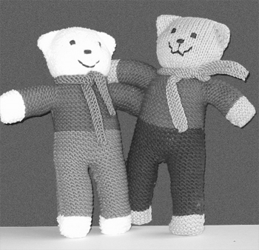

TRAUMA TEDDY
The Red Cross organises the collection of the teddies, which are then distributed via the Ambulance Service, the Fire Brigade and hospitals to children who have experienced a trauma. The pattern describes a teddy with pants and a shirt, but the pattern can be varied. The main thing is that the teddy has a personality of its own. There are variations of the pattern on the internet which you can use.

Suggested Pattern
YARN: Double knitting (no angora or mohair) Preferably washable
NEEDLES: No. 9 (3.75 mm) or no. 10 (3.25mm) needles (Loose knitters use No 10)
LEGS & PANTS: Leg 1: Cast on 12 stitches. Knit 34 rows. Change colour for pants and knit 8 rows. Leave stitches on the needle. Leg 2: Same as Leg 1
Pants: Join legs by knitting across both legs. Knit 14 rows to finish pants
BODY: With all 24 stitches on one needle change colour for shirt. Knit 18 rows.
Sleeve: Cast on 12 stitches at the beginning of the next 2 rows. Knit 18 rows.
Next 2 rows cast off 12 stitches (this forms the arms – 24 stitches remain)
Alternatively – do not increase for arms but once head is sewn together, pick up 8 stitches either side of the neck (16 Stitches) and knit 20 rows plus 10 rows main colour for hands.
HEAD: Knit 34 rows. Cast off .Repeat the instructions to obtain the other side of the Teddy
Or do not cast off but repeat the instructions in reverse order for the second side
FINISHING: Sew on face. Join up leaving a gap at the top of the head for filling
Form ears with stitching before filling
FILLING: Should preferably be new polyester or acrylic but can be wool. No foam.

Page 12
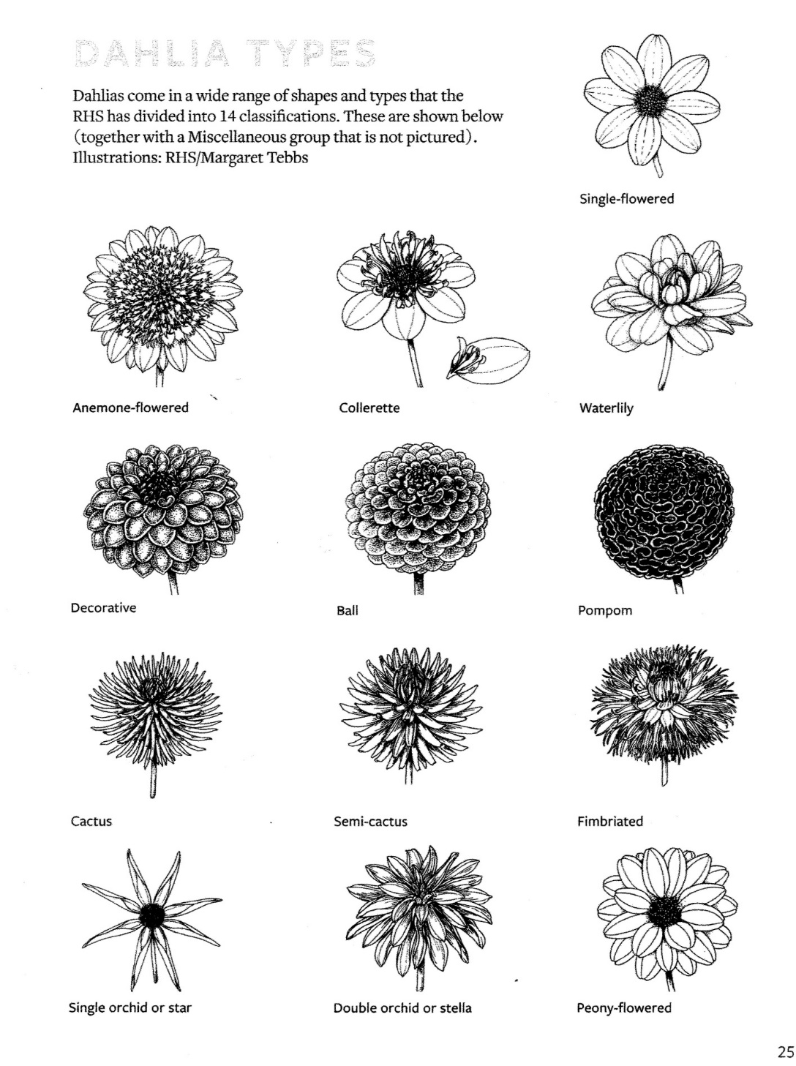
SECTION C
DAHLIA – OPEN

CLASS

54. The Alresford Dahlia CHAMPIONSHIP CLASS
3 Vases, 3 Distinct classifications, 3 Blooms per vase
Giants and / or large may be staged 1 per vase
55. Small Dahlia CHAMPIONSHIP CLASS
3 Vases, 3 Distinct cultivars, 3 Blooms per vase
chosen from at least 2 distinct classifications
i.e. Cactus,/ Semi cactus, Decorative, Ball or Waterlily may be used
56. 3 Giant and or Large, Decorative, Cactus / Semi Cactus
May be staged singly
57. 3 Medium Decoratives
58. 3 Medium Cactus / semi Cactus
59. 3 Small Decoratives
60. 3 Small Cactus / Semi Cactus
61. 3 Small Ball
62. 3 Miniature Ball
63. 3 Miniature Decoratives
64. 6 Pompon
65. 3 Blooms of one classification not mentioned in classes 56 to 64

DAHLIA – NOVICES

66. 3 Decorative Dahlias, one or more cultivars in one vase
67. 3 Cactus or Semi-Cactus Dahlias, one or more cultivars in one vase
68. 5 Pompon Dahlias, one or more cultivars in one vase
69. 1 Dahlia, any cultivar or type in a vase
70. 5 Single flowered Dahlias

For Dahlia Classifications and Details - Please see page 13

SECTION D – FLOWERS

FUCHSIA – OPEN
CLASS

71. 6 Fuchsia Heads in Box (Supplied) – 1 Cultivar
72. 1 Fuchsia - Single Flowered Cultivar - Pot Size 17cm
73. 1 Fuchsia Double Flowered Cultivar - Pot Size 17cm
Page 14
SECTION D – FLOWERS continued

ROSES – OPEN

75. 3 Stems Cluster Flowered Roses in 20cm vase
76. 3 Stems of any Rose/s. To be displayed in a vase, any size
77. 1 Specimen Bloom Large Flowered Rose. To be displayed in a vase, any size
78. 1 Bowl of roses, one or more cultivars, rose foliage only. Bowl to be supplied by exhibitor
Max exhibit size 30cm

GENERAL FLOWERS – OPEN
79. 3 Chrysanthemums – any cultivar including sprays
80. 1 Hydrangea
81. 3 stems of Agapanthus
82. 3 Spikes of Gladiolus
83. 5 Stems of Zinnias
84. 1 Pot Pelargonium, variety other than in class 101, container up to 20cm
85. 3 Blooms of Clematis in a dish, 1 or more Cultivars
86. 5 stems of Rudbeckia, in a vase
87.* Pot Plant, foliage, container up to 20cm. Maximum total height 1m including pot
88.* Pot Plant, flowering, container up to 20cm. Maximum total height 1m including pot
(Excluding Pelargoniums or Fuchsias, but may include Orchids)
89. * 1 Cactus or succulent, container up to 20cm
90. * A bowl of succulents - max bowl size 30cm diameter.
91. Vase of cultivated flowers, 12 spikes of at least 3 cultivars
92. A vase of dried flowers and seed heads
93. Berried shrubs, 3 stems, 3 different species
97. Asters 5 stems - in a vase
98. Sunflowers, 3 stems, one or more cultivars, any stage of development – in a vase
100. Sedums, 3 stems, one or more cultivars – in a vase
101. Alresford and District Hort. Soc. members only, given Pelargonium, pot grown

*Must be in owner’s possession for at least 6 MONTHS

The Royal Horticultural Society’s Banksian Medal is awarded to the winner of the highest number of place points in the whole of the horticultural classes at the show. See also Rule 13.

Page 15

SECTION E
FLORAL ART - OPEN

To be judged in accordance with the
NAFAS Competitions Manual, Third Edition 2015

NOTES FOR COMPETITORS

1. An Exhibit
a) is composed of natural plant material, with or without accessories contained within a
space as specified in a show schedule
b) backgrounds, bases, containers, drapes, exhibit titles and mechanics may always be
included in an exhibit unless otherwise stated
c) more than one placement may always be included unless otherwise stated
d) in all exhibits (except Still Life) natural plant material must predominate
2. No height restrictions except where stated
3. A novice is an exhibitor who has never won a cup at this Show
4. All exhibits may be brought to the Show completed
5. All exhibits staged on tables covered in black plastic

CLASS

102. “Anniversary Celebration” CHAMPIONSHIP CLASS
May include a relevant card. Will be viewed from the front
Space allowed 76 cm wide x 61 cm deep
103. “Bollywood Stars”
An exhibit - To be viewed from the front
Space allowed 61 cm wide x 61 cm deep
104. “What Bees Love’’
An exhibit - To be viewed and judged from the front
Space allowed 46 cm wide x 46 cm deep
105 “A Fairy Garden”
Miniature exhibit - To be viewed all round
displayed on a black 12cm square block provided
Size not to exceed 10 cm in width and depth, and 15cm in height
106. “Freshly picked” NOVICES ONLY
An arrangement in a basket or trug to include flowers and fruit.
This will be viewed and judged from the front
Space allowed 46 cm wide x 61 cm deep

Page 16

CULINARY
Plastic dome covers will be provided for entries once they are on the table. Dome sizes are 27cm and 19cm, exhibits must fit under a dome. Please leave domes in tent at the end of the show. Please see Hints & Information for Exhibitors
CLASS
107. 1 Yeast based seeded loaf
108. Be inventive with a bread mix
109. 1 Traditional Victoria sandwich cake with jam filling
110. 5 decorated cup cakes
111. ‘Time for tea’ 5 different small cakes or biscuits
112. Tea bread - Ingredients:
- 300 ml (1/2 pint) strong black tea
- 450g (16oz) mixed dried fruit
- 225g (8oz) self-raising flour
- ½ teasp. mixed spice
- ½ teasp. ground cinnamon
- 100g (4oz) granulated sugar
- 1 large egg
- Sunflower oil to grease
Method:
- Measure tea into a jug and add mixed fruit. Cover and soak overnight to absorb tea and plump up.
- Preheat oven to 160 C (140C. fan) mark 3. Grease a 900g (2lb) loaf tin and line with baking parchment. Put flour and spices in a large bowl and mix well. Add sugar and stir.
- Add the soaked fruit and any remaining liquid, then add the beaten egg and stir until all ingredients are thoroughly combined.
- Tip into the prepared tin and smooth the top.. Bake for 1 ½ hours without opening the door. Check that a skewer inserted comes out clean. If not allow 5 min more baking time.
- Remove from oven and cool on a wire rack.
113. 5 Macaroons
114. A gluten free cake
115. 5 Savoury biscuits
116. 3 Vegan sausage rolls
117. 3 Eccles cakes
118. A jam filled Swiss roll
119. Jar of Marmalade, 450g (1 lb) approx..
120. Jar of Jam, 450g (1 lb) approx..
121. Jar of Jelly, 225g (8oz) approx..
122. Jar of Mature Chutney 450g (1 lb) approx..
123 Jar of pickled vegetable/s

Page 17
SECTION G - DESIGN AND CREATE

Display size for all entries in this section is 60cms max x 60cms max x 60cms max
unless otherwise stated. Items may be displayed flat or supported

CLASS

124. A picture no larger than 26cm x 21cm (to include mount but not framed)
125. A metal, ceramic or wooden object
126. A handmade card
127. Upcycling (something new from something old)
128. Open Class - An article which you have made (NOT A KIT)

SECTION H - TEXTILES
Display size for all entries in this section is
46cms max x 46cms max unless otherwise stated (items may be folded)

129. A knitted or crocheted item
130. A felted item – all methods
131. Design and make a toy
132. A decorated T-Shirt. Design printed and/or coloured
133. Any other item or technique not mentioned above
e.g. Patchwork, lace, embroidery, or collage
134. Trauma Teddy - please see page 12 for instructions of how to make, and the
Alresford and District Horticultural Society website for more information and photos
www.alresfordhorticultural.org

SECTION J - AMATEUR PHOTOGRAPHY

Photographs to be mounted, not larger than 36cm x 28cm to include mount

135. 1 Colour Print, “Past its best”
136. 1 Colour Print, ‘”Life in or on the water”
137. 1 Colour Print, “Weather”
138. 1 monochrome print, - Any subject
139. Under 12 years 1 Colour Print, “Found in the garden”
140. Under 17 years 1 Colour Print, “My relative – a portrait”

Page 18
SECTION K - CHILDREN’S CLASSES

FLOWER ARRANGEMENTS

CLASS

141. Under 8 years ‘’An arrangement in a tin can”
An exhibit of Flowers & Foliage
142. Under 12 years “An arrangement in an unusual container”
An exhibit of Flowers & Foliage
143. Under 17 years “An arrangement based on shades of one colour”
An exhibit of Flowers & Foliage

FOOD

All entries to be displayed on paper plates 23cm maximum

144. Under 8 years – 5 decorated biscuits
145. Under 12 years – 5 decorated cup cakes
146. Under 17 years – A decorated sponge cake 20-22 cm approx. diameter

DESIGN and CREATE

Maximum Sizes for Classes 147-152 are 60cm x 60cm x 60cm
Not a kit

147. Under 8 years – Mr & Mrs Potato Head
148. Under 12 years – A paper and paste mask
149. Under 17 years – Something for the garden made with upcycled materials
150. Under 8 years – Open Class. An article which you have made yourself
151. Under 12 years – Open Class. An article which you have made yourself
152. Under 17 years – Open Class. An article which you have made yourself

Page 19
Alresford & District Horticultural Society are most grateful to the following businesses for their generous sponsorship

C E Evans & Son, High Class Family Butcher
8 West Street, Alresford
01962 732477 www.ceevansandson.co.uk

Sole Butchers Ltd
Butchers and Game Dealers of Distinction
5 Broad Street, Alresford
01962 735221 www.solebutchersofalresford.co.uk

D Barker & Son
Goldsmiths & Silversmiths
40a West Street, Alresford SO24 9AU
01962 732200 www.dbarkerandson.co.uk

D&G Hardware
Broad Street, Alresford, SO24 9AR
01962733133

Printed by DG Design and Print

